**FABRICATION OF   
MODIFIED SCOTCH YOKE MECHANISM**

**PROJECT REPORT**

Submitted *in partial fulfilment of the requirements for the award of the degree of*

**Bachelor of Technology**

***in***

**Mechanical Engineering**

By

|  |  |
| --- | --- |
| **AISWARYA NAMBIAR T -** | **(B220132ME)** |
| **S DEEPAK -** | **(B221168ME)** |
| **SHRISTY SHARMA -** | **(B221211ME)** |

**ME3193D PRODUCTION ENGINEERING LABORATORY II**

*Under the guidance of***Dr. Vikash Kumar**



Department of Mechanical Engineering

NATIONAL INSTITUTE OF TECHNOLOGY CALICUT

**April 2025**

**CERTIFICATE**

This is to certify that the report entitled:***“*FABRICATION OF  
MODIFIED SCOTCH YOKE MECHANISM***”* is a bonafide record of the **Project** presented by **AISWARYA NAMBIAR T (**Reg. No: **B220132ME)**, **S DEEPAK (**Reg. No: **B221168ME)**, **SHRISTY SHARMA (**Reg. No**: B221211ME)** under my supervision, in partial fulfilment of the requirements for the award of the degree of **Bachelor of Technology in Mechanical Engineering** from **National Institute of Technology Calicut** and this work has not been submitted elsewhere for the award of a degree.

**Dr. Vikash Kumar**

(ME3099D - Seminar)

*Dept. of Mechanical Engineering*

**Dr. ML JOY**

**Professor & Head**

*Dept. of Mechanical Engineering*

*Place* : NIT Calicut

*Date* : April 2025

**ACKNOWLEDGEMENT**

The success and final outcome of this project required a lot of guidance and assistance from many people and we are extremely privileged to have got this all along the completion of my project. All that we have done is only due to such supervision and assistance.

We are grateful to Dr. ML JOY (HOD, Mechanical Department), for providing us an opportunity to do the project work in the Mechanical Central Workshop and giving us all support and guidance, which allowed us to complete the project duly.

We owe our deep gratitude to our project in-charge Dr. Vikash kumar, who took keen interest in our project work and guided us all along, till the completion of our project work by providing all the necessary information for developing a good system.

We are also extremely thankful to and fortunate enough to get constant encouragement, support and guidance from all staff in the Central Workshop which helped us in successfully completing our project work. Also, we would like to extend our sincere gratitude to all Teaching Staff of the Mechanical Department for their timely support.

**ABSTRACT**

The **Rack and Pinion with Scotch Yoke Mechanism** is a mechanical system designed to convert rotary motion into precise linear reciprocating motion. This report explores its design, fabrication, assembly and real-life application in mechanical systems. The mechanism consists of two linear racks, a central pinion (spur gear), four rollers, a Scotch yoke, and a crank or actuator. When rotary input is applied to the crank, the Scotch yoke connected to the crank provides smooth reciprocating motion. While the pinion engages with the racks, moving them in opposite linear directions.

The design was meticulously developed through CAD modeling and simulated stress analyses, and subsequently fabricated in our production lab. This mechanism is widely used in cutting machines, presses, valve actuators, and automotive steering systems due to its efficient motion transfer and minimal backlash. The integration of the Scotch yoke ensures continuous, smooth reciprocation, reducing mechanical wear compared to conventional crank mechanisms. Additionally, the system can be optimized for force transmission and speed control based on rack and pinion size ratios.

The proper selection of materials, design, and installation is crucial to the successful operation of the scotch yoke mechanism. Maintenance and periodic inspection are also necessary to ensure the mechanism’s continued performance and safety.

**Components List:**

1. Linear Racks
2. Central Pinion Gear
3. Scotch Yoke
4. Crank/Actuator
5. Rollers
6. Supporting Frame

**TABLE OF CONTENTS**

**INTRODUCTION**

The Modified Scotch Yoke Mechanism is an innovative design that enhances the conversion of rotary motion into precise linear reciprocating motion. This mechanism, fabricated using conventional manufacturing processes such as lathe, shaper, and welding, consists of a central pinion gear meshed with two parallel racks, a lever to drive the pinion, and a supporting frame to ensure stability. The system is particularly useful in scenarios requiring controlled linear actuation, such as in cutting devices, production lines, vehicle steering, etc. By leveraging the mechanical advantage of the lever and the precision of the rack and pinion arrangement, this mechanism provides a reliable and manually operated solution for transmitting motion and force in industrial settings.

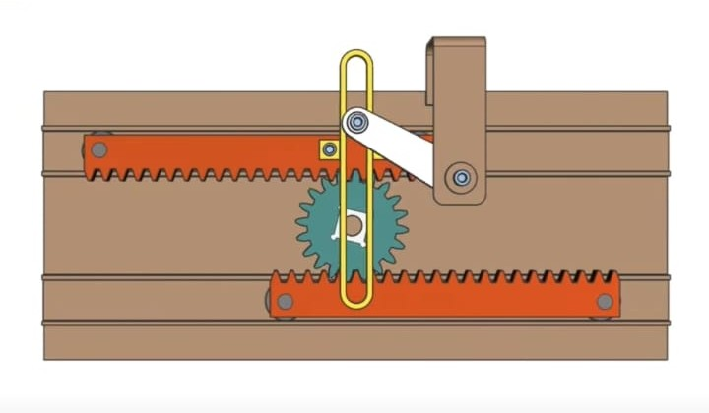

Fig 1: Modified Scotch Yoke Mechanism

**Operations:**

**1.** **Lever Actuation**: The process begins with the manual operation of the lever, which is rigidly attached to the pinion shaft. When the user applies a force to the lever, it rotates the pinion gear around its axis. The lever provides a mechanical advantage, allowing the user to apply a relatively small force to generate a larger torque on the pinion.

**2. Pinion Rotation**: As the lever rotates, the pinion gear, which is meshed with the teeth of the two parallel racks, also rotates. The pinion’s teeth engage with the rack teeth, converting the rotational motion of the pinion into linear motion of the racks.

**3. Linear Motion of Racks**: The two racks, positioned on opposite sides of the pinion, move linearly in opposite directions due to the pinion’s rotation. For example, if the pinion rotates clockwise, the upper rack moves to the left, and the lower rack moves to the right. This synchronized motion ensures balanced operation and can be used to actuate components attached to the racks.

**4. Force Transmission:** The linear motion of the racks can be used to transmit force to external components, such as pushing or pulling a load, clamping an object, or adjusting the position of a tool. The system’s design ensures that the motion is precise and proportional to the angle of lever rotation.

**5. Return Motion**: When the lever is rotated in the opposite direction, the pinion reverses its rotation, causing the racks to move back to their original positions or in the opposite linear direction. This bidirectional operation makes the mechanism versatile for various applications.

The mechanism operates smoothly when the gear teeth are properly meshed, and friction is minimized through lubrication and precise machining. The frame ensures that the racks remain aligned and move within their designated slots, preventing misalignment or binding during operation.

**Types of Mechanism**

The mechanism depicted in the image is a specific configuration of a rack and pinion system with a lever, but it can be categorized and extended into various types based on design variations and applications. Below are the types of mechanisms related to this system:

**1. Scotch Yoke Mechanism**:

- The Scotch Yoke mechanism converts rotary motion into linear motion using a slotted yoke and a crankpin. As the crank rotates, the pin moves within the yoke slot, causing it to reciprocate. This mechanism is used in piston engines, valve actuators, and presses due to its smooth motion and high force output.

- Application: Valve Actuators, Cutting Machine, etc.

**2. Basic Rack and Pinion Mechanism**:

- This is the core mechanism in the system, where a circular pinion gear engages with a linear rack to convert rotational motion into linear motion or vice versa. In the given setup, the pinion is driven by a lever, and the racks move linearly in opposite directions.

- Application: Used in automotive steering systems, linear actuators, and sliding gates.

**3. Bidirectional Linear Actuator:**

- The mechanism can be classified as a bidirectional linear actuator because the racks can move in both directions (left or right) depending on the direction of the lever’s rotation. This versatility allows the system to perform tasks like opening/closing or pushing/pulling.

- Application; Used in adjustable mechanisms, such as in furniture (e.g., recliner adjustments) or industrial tools requiring reversible motion.

**Summary**

The rack and pinion mechanism with a lever operates by converting the rotational motion of the lever-driven pinion into linear motion of the racks, with the two racks moving in opposite directions for balanced operation. The mechanism can be classified into various types, including a double rack and pinion system, lever-driven mechanism, guided rack mechanism, and bidirectional linear actuator, each offering specific advantages for different applications. This design highlights the versatility and practicality of combining simple mechanical elements to achieve controlled motion in engineering systems.

**DESIGN OF THE MODEL**

**Determination of part dimensions**:

In the initial CAD model, the parts were dimensioned according to dimensions. Later, changes were made owing to the material available in the workshop and module restrictions. All the links, disc and shaft dimensions were changed. Optimum lengths of the links , discs, shaft was obtained by constructing a 2D drawing of the mechanism and tracing its locus in the plane.

**FABRICATION OF THE MODEL**

Week 1:

**ANALYSIS**

**FOR RACK:**



Fig: Displacement analysis



Fig: Velocity analysis



Fig: Accelaration analysis

**FOR CRANK:**



Fig: Displacement analysis



Fig: Motor Torque



Fig: Power consumption

**RESULT**

**CONCLUSION**

**FINAL PARTS**